**Task-2:**

**1.Creating 3 Vnets**

**2.reating Gateway Subnet and VPN Gateway**

**3.peering for Vnets**

**4.Creating vnet2 has hub and vnet3 has spoke**

1.Created Virtual network-1 in that created subnet1(Frontend).

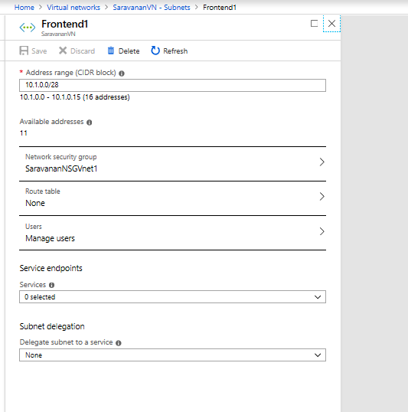

2.Created Virtual Network-1 in that Created subnet2(Backend).

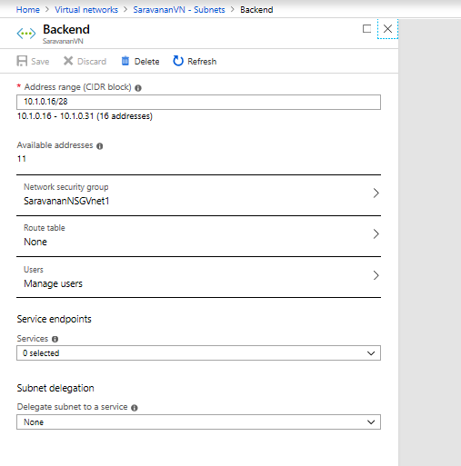

3.Created Virtual Network-2 in that Created subnet1(Frontend).

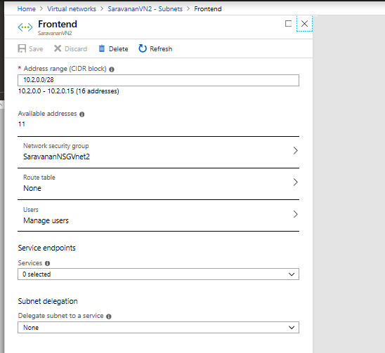

4.Created Virtual Network-2 in that Created subnet2(backend).

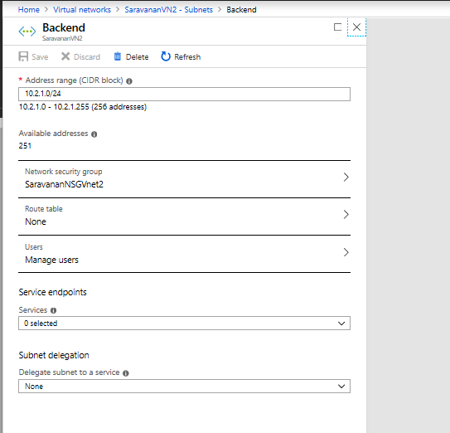

5.Created Virtual Network-3 in that Created subnet1(frontend).

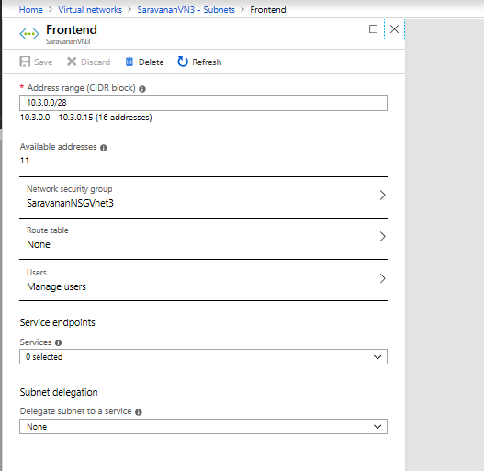

6. Created Virtual Network-3 in that Created subnet2(backend).

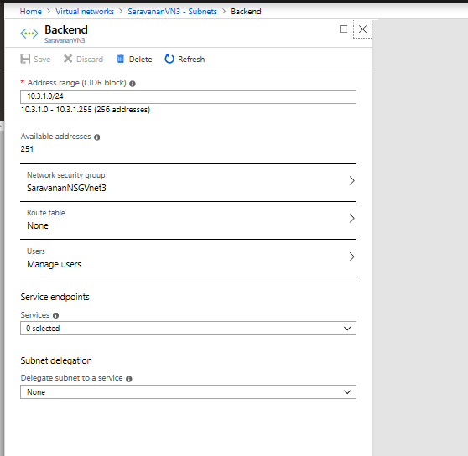

7.Created Gateway subnet in vnet1.

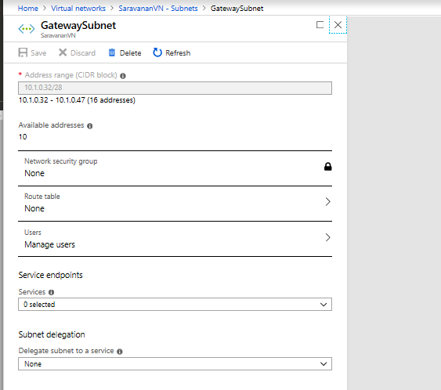

8.Created Gateway subnet in vnet2.

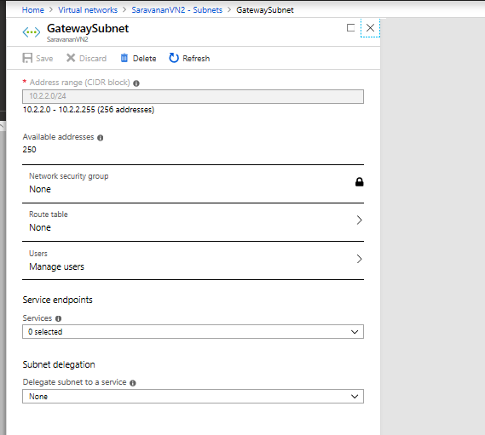

9.Created Gateway subnet in vnet3.

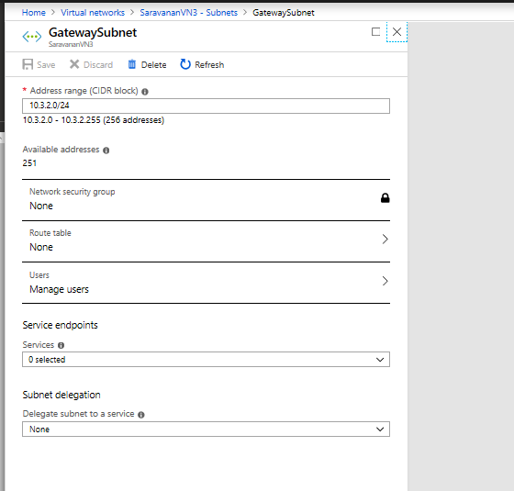

10.Created VPN Gateway in vnet1.

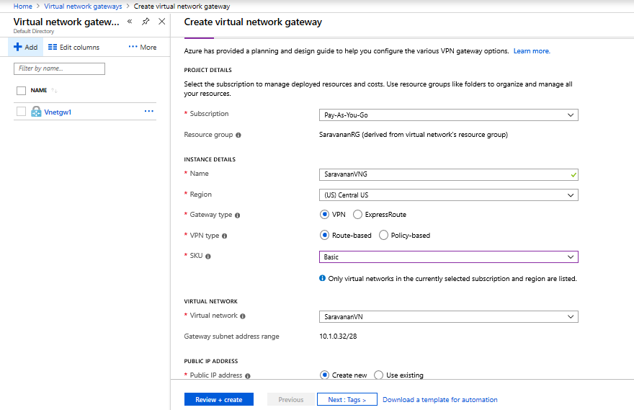

11.Created VPN Gateway in vnet2.

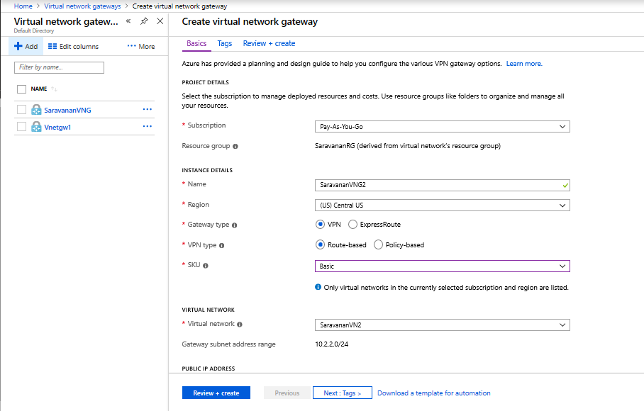

12.Adding connections to Vnet2 to Vnet3:

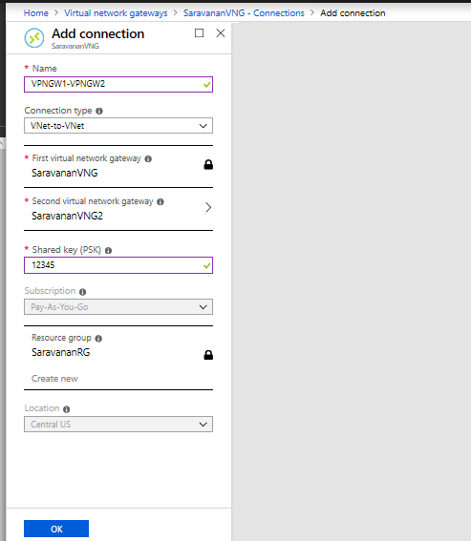

13.In Virtual Network-2 did Peering for hub.

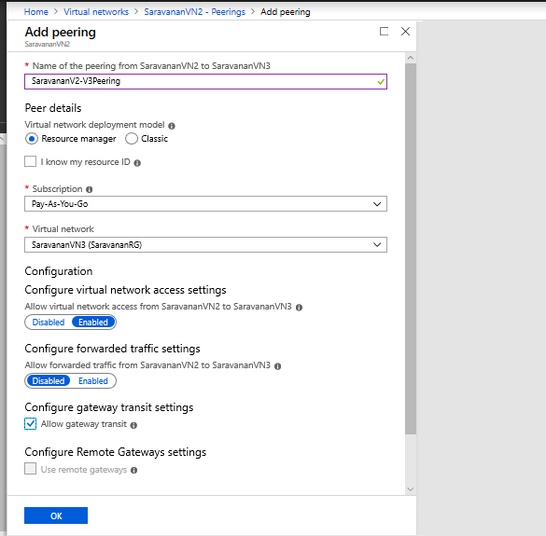

14. In Virtual Network-3 did Peering for Spoke.

